SUBJECT: OBJECT ORIENTED PROGRAMMING

Submitted To: Engr. Asmatullah

Submitted By: Asadullah Samo (21SW036)

Dated: 16-08-2022

Lab: Lab-06 Tasks

**Question 01:**

Write java code that takes a value at runtime and searches it in the array. If the value appears in the array then it prints the position of the value or else prints a message that value is not found.

Source Code:

**package** Lab_06_Tasks;

**import** java.util.Scanner;

**public** **class** Lab_06_Task_01 {

**public** **static** **void** main(String[] args) {

Scanner sc = **new** Scanner(System.in);

**int** [] array = {15, 27, 65, 98, 36, 51, 119, 42};

System.out.print("Enter a number to search in array: ");

**int** num = sc.nextInt();

**int** index = 0;

// initializing isPresent to false

**boolean** isPresent = **false**;

**for**(**int** i=0; i<array.length; i++){

**if**(array[i]==num)

{

// if number is present, set isPresent to true and exit from loop

isPresent = **true**;

index = i;

**break**;

}

} // end of for loop

// If number is found

**if**(isPresent==**true**){

System.out.println(num+" is found in array at index "+index);

} **else** {

System.out.println(num+" is not found in Array");

} // end of if else block

} // end of main() method

} // end of program

OUTPUT:



**Question 02:**

Write a java program to demonstrate the concept of java runtime arguments. Input your name and roll number and print it on the console.

Source Code:

**package** Lab_06_Tasks;

**public** **class** Lab_06_Task_02 {

**public** **static** **void** main(String[] args) {

System.out.println("Name: "+args[0]);

System.out.println("Roll Number: "+args[1]);

} // end of main() method

} // end of program

OUTPUT:

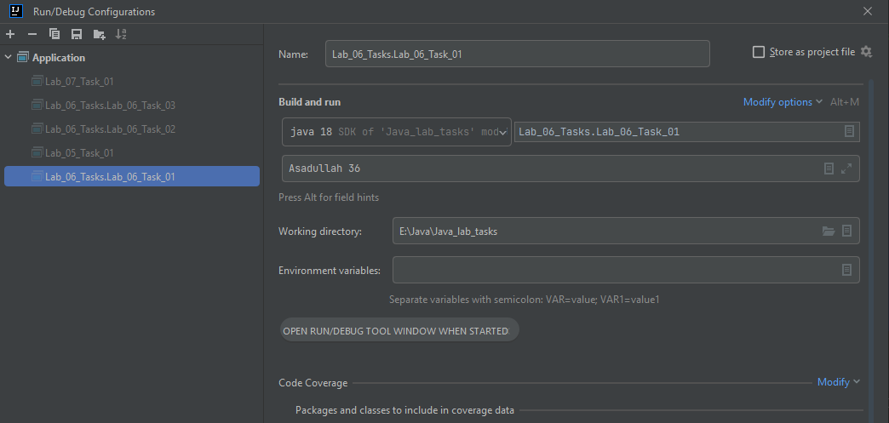

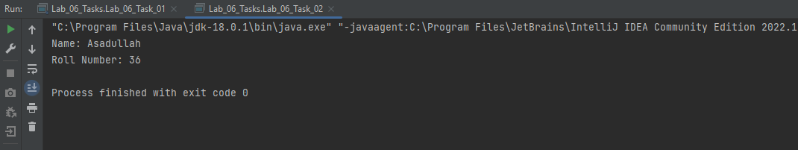

**Question 03:**

Develop a java program that takes 5 floating numbers as runtime arguments and print their total sum and average.

Source Code:

**package** Lab_06_Tasks;

**import** java.util.Scanner;

**public** **class** Lab_06_Task_03 {

**public** **static** **void** main(String[] args) {

Scanner sc = **new** Scanner(System.in);

**float** sum = 0;

**for**(**int** i=0; i< args.length; i++){

// To convert String into floating point numbers for calculation

**float** f = Float.valueOf(args[i]);

sum = sum + f;

}

System.out.println("Average is "+sum/5);

} // end of main() method

} // end of program

OUTPUT: 

